
HWA CHONG INSTITUTION
JC2 Preliminary Examination
Higher 1

CANDIDATE NAME |  |  |  |  |  |  | CT GROUP
CENTRE NUMBER |  |  |  |  |  |  | INDEX NUMBER

GEOGRAPHY  Paper 1  INSERT | 8834/01  11 September 2024  3 hours

READ THESE INSTRUCTIONS FIRST
This Insert contains all the Resources referred to in the questions.

________________________________________________________________________
This document consists of 8 printed pages

[Turn over
Resource 1 for Question 1

Street-level views outside Bugis Junction
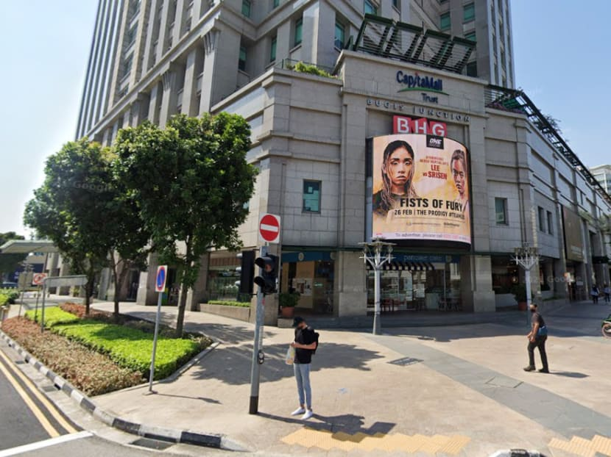
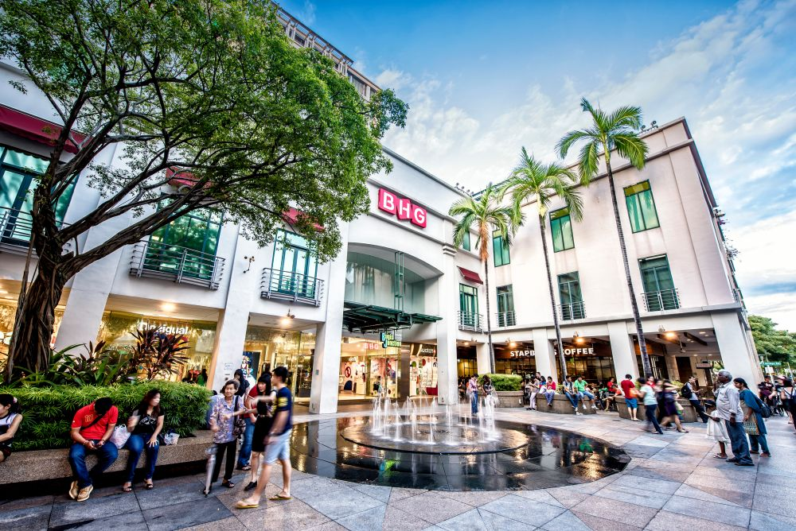

Resource 2 for Question 1

Surveyed Singapore consumers’ perception of different actors’ importance in fighting climate change
Government has a part to play in fighting climate change

Businesses have a part to play in fighting climate change

Community groups have a part to play in fighting climate change

NGOs have a part to play in fighting climate change

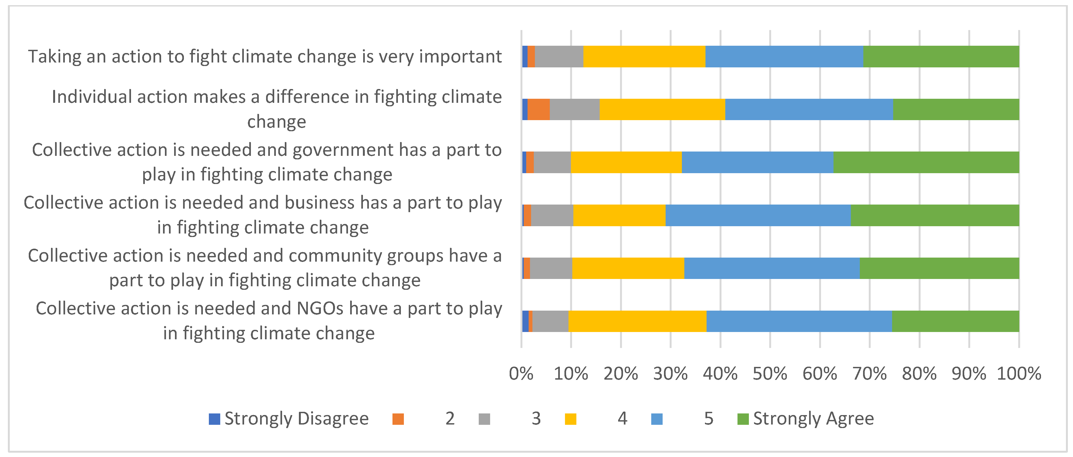

Resource 3 for Question 1

2019 selected survey findings by NCCS about Singapore consumers’ perception on the
responsibility of different actors in fighting climate change
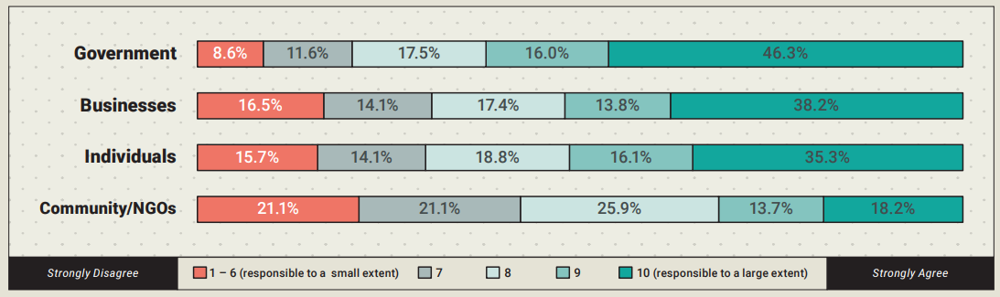
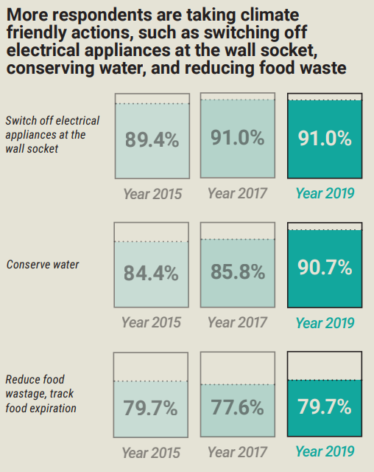
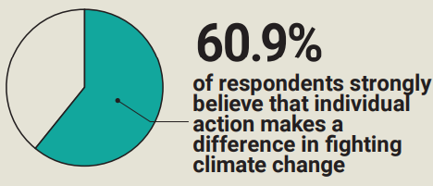

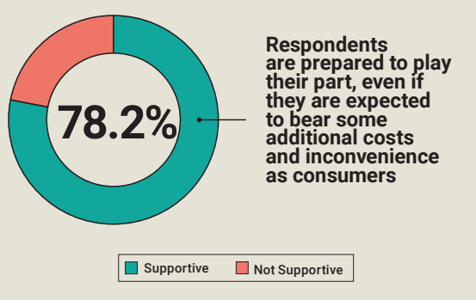

Resource 4 for Question 2
Urban growth in selected cities
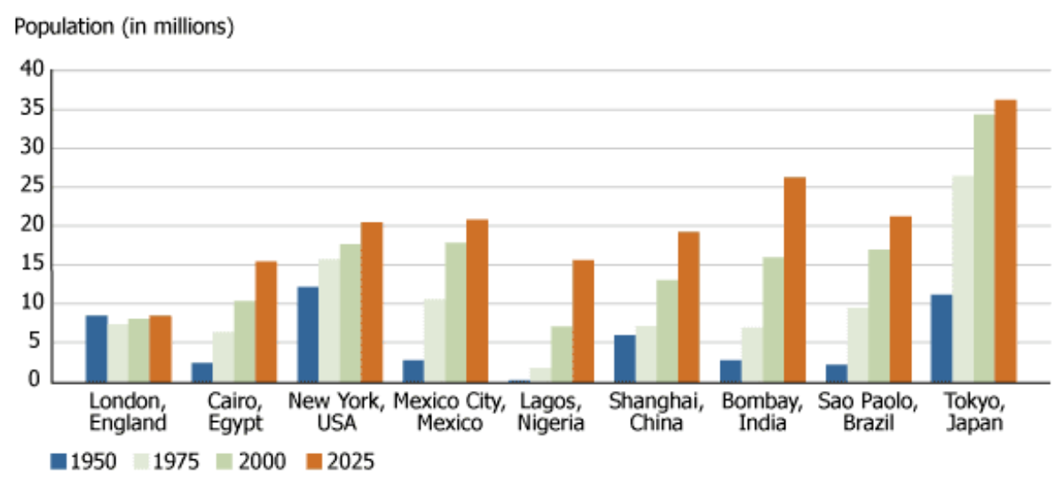
Mumbai,
India

Resource 5 for Question 2

Urban population annual growth rates in primary cities and suburbs in
New York and Boston metropolitan areas 2010 - 2020

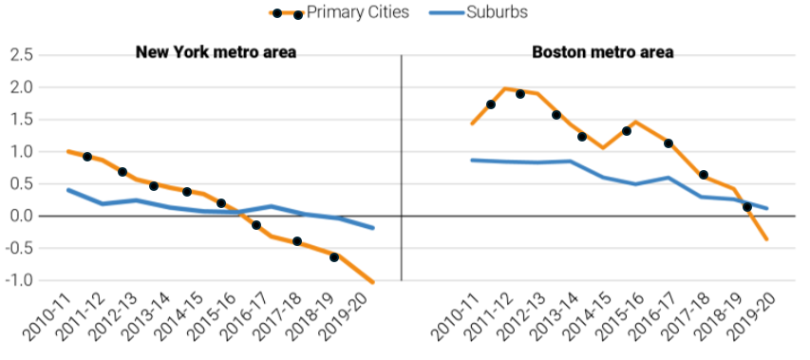

Resource 6 for Question 2

Some details of the Deonar dumping ground fire in Mumbai, India and its location within the Mumbai Metropolitan Region

Major town in Mumbai

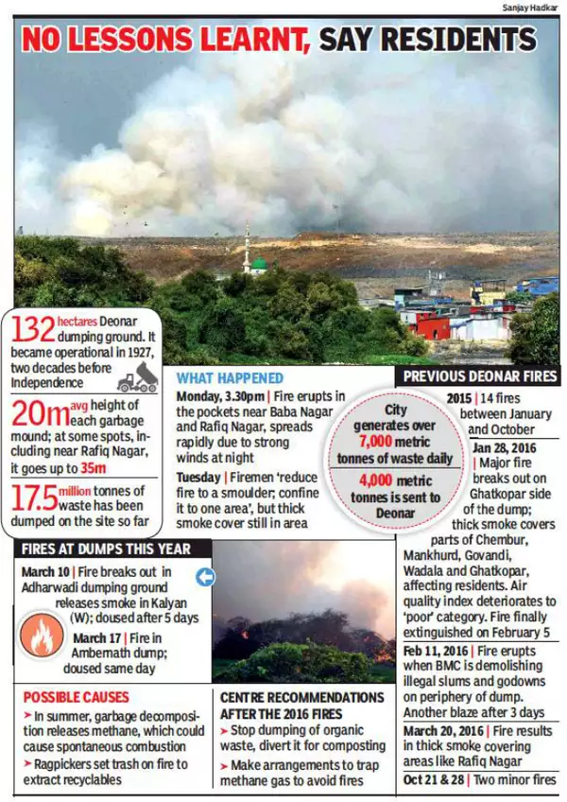

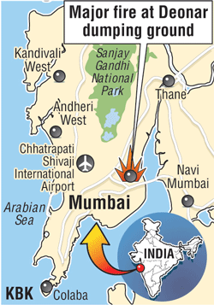

Resource 7 for Question 2

Solid waste production in Mumbai and Sweden and
solid waste management by Tekniska Verken in Sweden
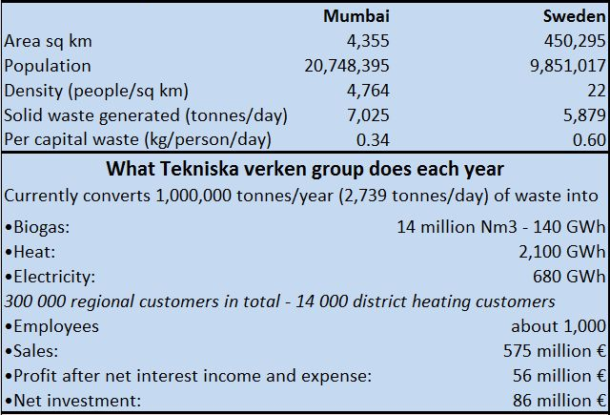

What Tekniska Verken does in Sweden each year

* Tekniska Verken is a major Swedish multi-utility energy company
* Mumbai generates 5 025 tonnes of mixed waste (bio-degradable and recyclable)

Resource 8 for Question 3

Changes in global surface temperature between 1880 to 2020

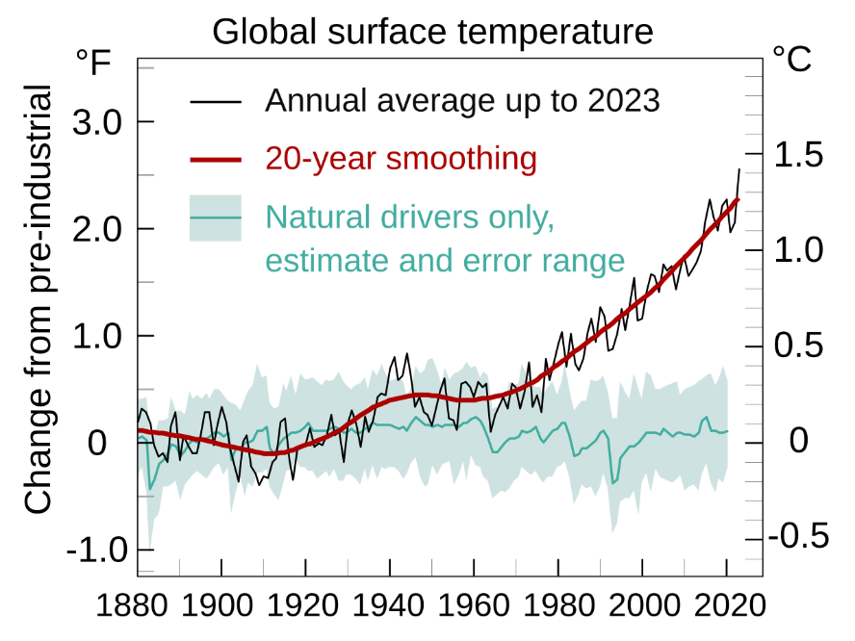

Resource 9 for Question 3

Effects of major drivers on biodiversity in Earth’s ecosystems

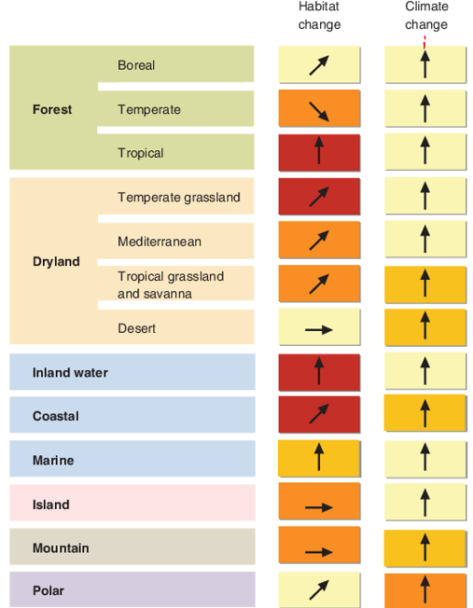

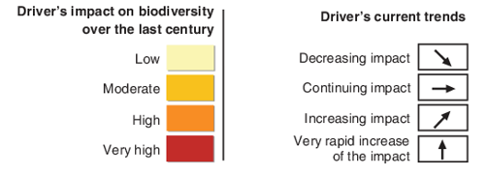

Resource 10 for Question 3

Global warming and the tipping points of Earth’s climate systems

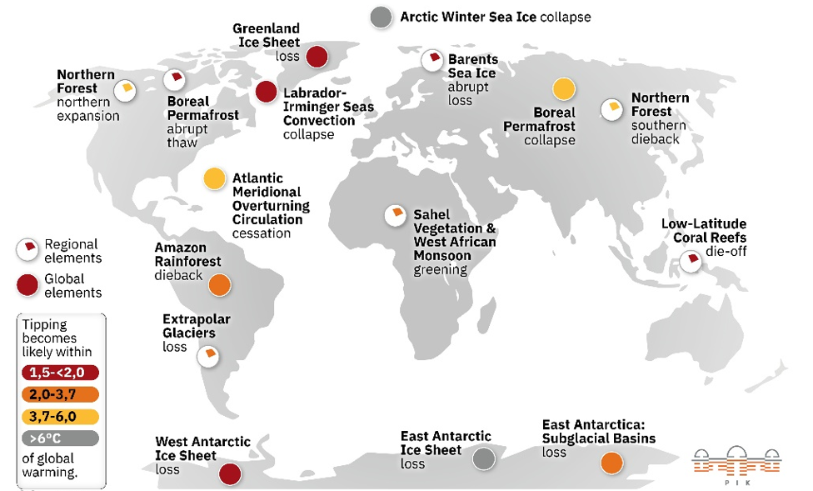

* Tipping points are 'critical thresholds in a system that, when exceeded, can lead to a significant change in the state of the system, often with an understanding that the change is irreversible

_______________________________________________________________________________________________________________________________________________
Acknowledgements
Question 1 Resource 1 @ https://www.capitaland.com/sg/
Question 1 Resource 1 @ https://www.todayonline.com/singapore/
Question 1 Resource 2 @ https://www.mdpi.com/2071-1050/14/19/12330
Question 1 Resource 3 @ https://www.nccs.gov.sg/
Question 2 Resource 4 @ https://www.internetgeography.net/topics/what-is-urbanisation/
Question 2 Resource 5 @ https://www.brookings.edu/
Question 2 Resource 6 @ https://www.ibtimes.co.in/photos/
Question 2 Resource 7 @ https://asiaconverge.com/2016/03/669/
Question 3 Resource 8 @ https://www.ipcc.ch/report/ar6/wg1/figures/summary-for-policymakers
Question 3 Resource 9 @ https://www.semanticscholar.org/paper/
Question 3 Resource 10 @ https://www.pik-potsdam.de/en/output/infodesk/tipping-elements

